Weerts Logistics Parks is a building state-of-the-art, environmentally friendly logistics park on nearly 80 football fields worth of land
Press Release/ PResstonPR/ April 25th, 2023.
Nowadays, protection of the environment plays a significant role in all industries. Green principles aren’t empty talk anymore, but rather an investment for companies as they are the key to the future. The measures that these companies take aren’t only cost effective, they also try to reduce their ecological footprint with environmentally friendly solutions.
Weerts Logistics Parks (WLP) and RaktárAD, a company group with a Belgian-Hungarian ownership, are undertaking their 25th project within Europe in Vecsés. They already have successfully operational modern warehouses under their belt, 15 in Belgium, two each in Germany and the United Kingdom, as well as single projects in the Netherlands, Italy, and France. This is the third investment in Hungary that is related to the consortium.
The favorable location is appealing to Hungarian businesses as well
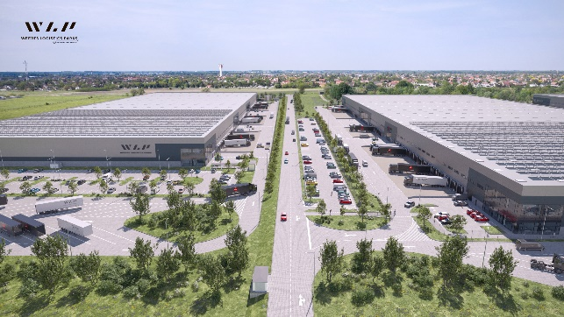
The latest project of WLP is located on the border of Vecsés and Gyál in Aratás street, offering excellent logistics and location related advantages. On the site spanning several acres, four buildings will be erected, each with a size of 50,000 square meters, totaling nearly 200,000 square meters.
The Liszt Ferenc International Airport in Budapest is merely 11 minutes away. The warehouses can serve as an ideal base for those involved in airborne, rail, and road freight transport.
The Belgian-Hungarian owned RaktárAD and WLP developer group placed a great emphasis on environmental protection during the planning and execution of the 60-acre logistics center in Vecsés. With the current construction works on the site, the investor is replicating the same concept of RaktárAD that has already been successfully implemented in Nagytarcsa and Alsónémedi over the past seven years.
Photo credit: Weerts Logistics Parks (WLP)
Industrial business parks which alleviates the discomfort of residents
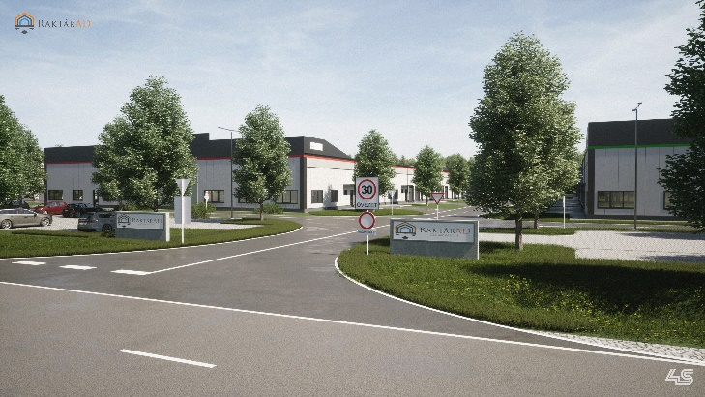
The RaktárAD project is an open project without fences, specifically designed to accommodate small and medium-sized enterprises (SMEs) that have previously been operating in residential areas. These warehouse buildings are industrial business parks where entrepreneurs will be able to purchase spaces. The warehouses are designed to be easily accessible and have a transparent location. The investment will primarily benefit Gyál, Vecsés, and district XVIII, as the logistics park will alleviate the discomforst of the surrounding streets caused by truck traffic and of small, scattered workshops operating in the residential areas. The investment is expected to create nearly 1000 work places.
Photo credit: RaktárAD
Utilizing renewable energies to preserve the environment and reduce utility costs
The investor places a great emphasis on the use of energy-efficient solutions, therefore they have commissioned a separate engineering office to work on developing state-of-the-art technologies.
The buildings have environmentally friendly parameters so that the energy-saving building engineering solutions would be able to reduce environmental harm and be expanded with further alternative energy sources in the future.
Cost-effective energy use is ensured by excellent insulation
The heating of the "A" category warehouse buildings will be provided by sustainable heat pump solutions instead of gas, which can be complemented with solar panels upon request of the tenants. Panels and windows with higher insulation values compared to what are required by regulations can significantly reduce – up to 50% – the energy bills of companies moving in. These cost cuts can be invested in the growth of businesses.
With sustainability in mind the WLP warehouses use renewable energy technologies, which is why they were assigned to the Very Good category of the state-of-the-art BREEAM evaluation. BREEAM (Building Research Establishment’s Environmental Assessment Methodology) is the most popular and well-known international standardized environmental certification system in the real estate market. It indicates significant prestige value among tenants and serves as guarantee for the quality of a new investment.
This certification is accredited due to the innovative, efficient, and environmentally conscious solutions such as waste management, paperless communication, and completely barrier-free ground floor areas for individuals with disabilities.

Creating green areas to increase comfort of city dwellers
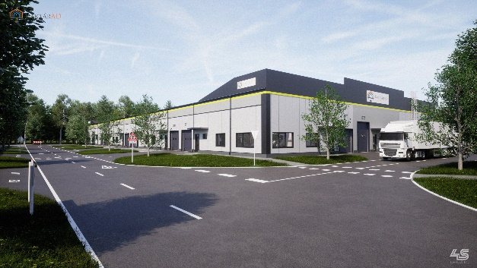
Legal regulations require a green strip to be designated along the edge of the premises. This is a 20-meter area where neither parking nor halls can be built, but instead three levels of vegetation must be planted. The complete landscaping of the logistics park will be implemented in 4 stages over a period of 4-5 years.
Photo credit: RaktárAD
Adoption of the Western European model results in water savings
WLP plans to implement the use of graywater, which already is a widespread practice in Western Europe, with the project in Vecsés as well. In coordination with the local service provider, where permission is granted, they would like to use this water to flush the restrooms, and to water the lawn and garden.
"The facility meets the strictest requirements of cutting-edge technology and sustainability. It sets an example for the premium category, green logistics centers of the future." - emphasized Tibor Lőrincz-Hadnagy, COO & Operations Manager of the project.

A brief introduction of WLP and RaktárAD:
RaktárAD and WLP (Weerts Logistics Parks), a Belgian-Hungarian owned consortium develop warehouses in Vecsés for SMEs.
Weerts Logistics Parks (WLP) has already invested in over 1,000,000 m2 of state-of-the-art logistics facilities in Belgium, the Netherlands, France, Germany, the United Kingdom, and Italy.
Over the past six years, it has built nearly 202,000 square meters of facilities, creating 905 jobs, and housed several Hungarian companies.
This is the 25th project of WLP to be implemented within Europe and its third investment in Hungary.
The project management company of the consortium, HAD Consult, has already supported numerous successful projects through its excellent team of professionals.

For further information and interviews please contact:
Adrienne Terdik | Managing director | PResston PR | Rózsadomb Center |
1025 Budapest | Törökvész u. 87-91. | T + 36 1 325 94 88 | F +36 1 325 94 89 |
M +36 30 257 60 08 | adrienne.terdik@presstonpr.hu |www.presstonpr.hu
Zsuzsanna Tüske | Senior PR Account | PResston PR | Rózsadomb Center |
1025 Budapest | Törökvész u. 87-91. | T + 36 1 325 94 88 | F +36 1 325 94 89 |
M +36 30 831 64 56 | zsuzsa.tuske@presstonpr.hu |www.presstonpr.hu

